

**AMERICAN INTERNATIONAL UNIVERSITY–BANGLADESH (AIUB)**

**FACULTY OF SCIENCE & TECHNOLOGY**

**DEPARTMENT OF COMPUTER SCIENCE**

**INTRODUCTION TO DATABASE**

**Fall 2022-2023**

**Section: A**

**PROJECT ON**

Apartment Management System

**Supervised By**

*Juena Ahmed Noshin*

|  |  |  |  |
| --- | --- | --- | --- |
| Name | | ID | Contribution |
| Iffat Shamia Shairy | 22-46703-1 | | Normalization, Schema Diagram, Conclusion |
| Ajmy Alaly | 22-46733-1 | | Introduction, Scenario Description, ER Diagram |
| Faysal Ahmmed | 22-47069-1 | | Data Insert, Query Writing |
| Md. Asifur Rahman Sayem | 22-47092-1 | | Table Creation, Relational Algebra |

**Submitted By**

Date of Submission: **December 26, 2022**

**TABLE OF CONTENTS**

|  |  |  |
| --- | --- | --- |
| **TOPICS** | | ***Page no*.** |
| 1. **Title Page** | | 1 |
| 1. **Table of Content** | | 2 |
| 1. **Introduction** | | 3 |
| 1. **Scenario Description** | | 3 |
| 1. **ER-Diagram** | | 4 |
| 1. **Normalization** | | 5 |
| 1. **Schema Diagram** | | 12 |
| 1. **Table Creation** | | 13 |
| 1. **Data Insert** | | 16 |
| 1. **Query Writing** | | 20 |
| 1. **Relational Algebra** | | 22 |
| 1. **Conclusion** | | 23 |
|  |

**Introduction:**

To manage the tasks and information of apartment or housing societies we require a software application which is known as an apartment management system. These systems collect all the data so that the tenants and the owner of a property can enjoy smooth processes for renting collection, maintenance, security, etc.

Our apartment management system also works in the same way. It collects data on every tenant who is living in the apartment. It collects information about the tenant’s maintenance bill, their vehicle details, their unit number in the apartment, etc. All these things can help apartment owners manage and maintain their apartments accurately and efficiently.

**Scenario Description:**

In an apartment management system, an apartment owner may have many apartments. But an apartment has only one apartment owner. An apartment is identified by its apartment number. The system also stores apartment name, apartment type, road number, and block. A block is composed of a block id and a block number. An apartment owner is identified by the apartment owner ID. Owner address, name, email, and phone number are also stored. An owner's address is composed of the house number, street name, and city. There may be multiple phone numbers for the owner. An apartment may have at least one unit, but a unit can only have one apartment. To identify the unit, the unit number is stored. Also, unit size and unit level are stored. A unit has a tenant. To uniquely identify tenants, their ID is stored. Tenants' name, phone number, email, date of birth, and age are stored. There may be multiple phone numbers for the tenant. Tenants' ages can be determined from their dates of birth. A tenant has to pay bills. A tenant can pay bills once a month, and a bill can be paid by only one tenant. To distinguish bills, bill id is stored. A bill consists of an electric bill, a gas bill, apartment rent, and a total amount. The total amount can be determined by adding all the bills. When a tenant pays the bill, the date is stored. The apartment owner takes the bill. An apartment owner can take many bills, but a bill can be taken only once by an apartment owner. An apartment owner may have vehicles, but a vehicle can only have one apartment owner. To identify vehicles, their number is stores. Also, vehicle brand, color, and type are stored along with the vehicle's allocation space to give the vehicle proper space in apartment parking. A tenant may also have vehicles. But a vehicle can have only one tenant. An apartment owner can manage many apartments, but an apartment can be managed by only one apartment owner. An apartment also has security guards to protect the apartment and its tenants. To identify guards differently, their ID is stored in the system. Also stored are their name, address, phone number, and salary. A security guard may have multiple phone numbers. An apartment can have many security guards, but a security guard can only give his or her service to one apartment at a time.

**ER Diagram:**

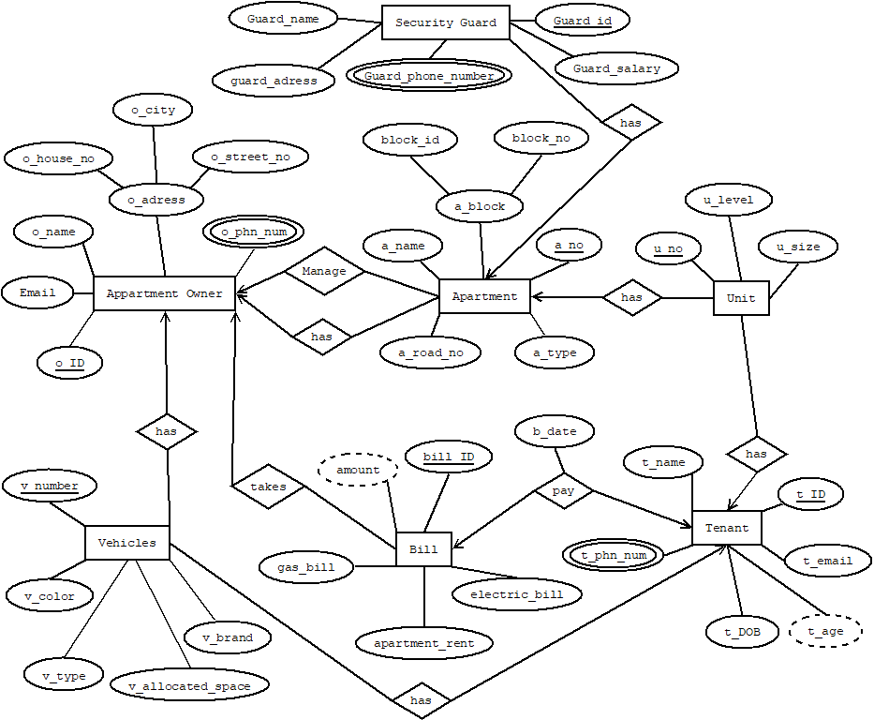

**Normalization:**

UNF:

Manage (o_id, email, o_name, o_house_no, o_city, o_street_no, o_phone_number, a_no, a_name, block_id, block_no, a_type, a_road_no)

1NF:

O_phone_number is a multivalued attribute.

1. o_id, email, o_name, o_house_no, o_city, o_street_no, o_phone_number, a_no, a_name, block_id, block_no, a_type, a_road_no

2NF:

1. o_id, email, o_name, o_house_no, o_city, o_street_no, o_phone_number

2. a_no, a_name, block_id, block_no, a_type, a_road_no

3NF:

There is no transitive dependency. Relation already in 3NF.

1. o_id, email, o_name, o_house_no, o_city, o_street_no, o_phone_number

2. a_no, a_name, block_id, block_no, a_type, a_road_no

Table Creation:

1. o_id, email, o_name, o_house_no, o_city, o_street_no, o_phone_number

2. a_no, a_name, block_id, block_no, a_type, a_road_no, **o_id**

UNF:

Has (o_id, email, o_name, o_house_no, o_city, o_street_no, o_phone_number, a_no, a_name, block_id, block_no, a_type, a_road_no)

1NF:

O_phone_number is a multivalued attribute.

1. o_id, email, o_name, o_house_no, o_city, o_street_no, o_phone_number, a_no, a_name, block_id, block_no, a_type, a_road_no

2NF:

1. o_id, email, o_name, o_house_no, o_city, o_street_no, o_phone_number

2. a_no, a_name, block_id, block_no, a_type, a_road_no

3NF:

There is no transitive dependency. Relation already in 3NF.

1. o_id, email, o_name, o_house_no, o_city, o_street_no, o_phone_number

2. a_no, a_name, block_id, block_no, a_type, a_road_no

Table Creation:

1. o_id, email, o_name, o_house_no, o_city, o_street_no, o_phone_number

2. a_no, a_name, block_id, block_no, a_type, a_road_no, **o_id**

UNF:

Has (a_no, a_name, block_id, block_no, a_type, a_road_no, u_no, u_size, u_level)

1NF:

There is no multivalued attribute. Relation already in 1NF.

1. a_no, a_name, block_id, block_no, a_type, a_road_no, u_no, u_size, u_level

2NF:

1. a_no, a_name, block_id, block_no, a_type, a_road_no

2. u_no, u_size, u_level

3NF:

There is no transitive dependency. Relation already in 3NF.

1. a_no, a_name, block_id, block_no, a_type, a_road_no

2. u_no, u_size, u_level

Table Creation:

1. a_no, a_name, block_id, block_no, a_type, a_road_no

2. u_no, u_size, u_level, **a_no**

UNF:

Has (a_no, a_name, block_id, block_no, a_type, a_road_no, guard_id, guard_salary, guard_phone_number, guard_adress, guard_name)

1NF:

Guard_phone_number is a multivalued attribute.

1. a_no, a_name, block_id, block_no, a_type, a_road_no, guard_id, guard_salary, guard_phone_number, guard_adress, guard_name

2NF:

1. a_no, a_name, block_id, block_no, a_type, a_road_no

2. guard_id, guard_salary, guard_phone_number, guard_adress, guard_name

3NF:

There is no transitive dependency. Relation already in 3NF.

1. a_no, a_name, block_id, block_no, a_type, a_road_no

2. guard_id, guard_salary, guard_phone_number, guard_adress, guard_name

Table Creation:

1. a_no, a_name, block_id, block_no, a_type, a_road_no

2. guard_id, guard_salary, guard_phone_number, guard_adress, guard_name, **a_no**

UNF

Has(u_no, u_size, u_level, t_id, t_email, t_DOB, t_name, t_phone_number)

1NF:

T_phone_number is a multivalued attribute.

1. u_no, u_size, u_level, t_id, t_email, t_DOB, t_name, t_phone_number

2NF:

1. u_no, u_size, u_level

2. t_id, t_email, t_DOB, t_name, t_phone_number

3NF:

There is no transitive dependency. Relation already in 3NF.

1. u_no, u_size, u_level

2. t_id, t_email, t_DOB, t_name, t_phone_number

Table Creation:

1. u_no, u_size, u_level, **t_id**

2. t_id, t_email, t_DOB, t_name, t_phone_number

UNF:

Pay(t_id, t_email, t_DOB, t_name, t_phone_number, bill_id, electric_bill, apartment_rent, gas_bill, b_date)

1NF:

T_phone_number is a multivalued attribute.

1. t_id, t_email, t_DOB, t_name, t_phone_number, bill_id, electric_bill, apartment_rent, gas_bill, b_date

2NF:

1. t_id, t_email, t_DOB, t_name, t_phone_number

2. bill_id, electric_bill, apartment_rent, gas_bill, b_date

3NF:

There is no transitive dependency. Relation already in 3NF.

1. t_id, t_email, t_DOB, t_name, t_phone_number

2. bill_id, electric_bill, apartment_rent, gas_bill, b_date

Table Creation:

1. t_id, t_email, t_DOB, t_name, t_phone_number

2. bill_id, electric_bill, apartment_rent, gas_bill, b_date, **t_id**

UNF:

Takes(. bill_id, electric_bill, apartment_rent, gas_bill, b_date, o_id, email, o_name, o_house_no, o_city, o_street_no, o_phone_number)

1NF:

O_phone_number is a multivalued attribute.

1. bill_id, electric_bill, apartment_rent, gas_bill, b_date, o_id, email, o_name, o_house_no, o_city, o_street_no, o_phone_number

2NF:

1. bill_id, electric_bill, apartment_rent, gas_bill, b_date

2. o_id, email, o_name, o_house_no, o_city, o_street_no, o_phone_number

3NF:

There is no transitive dependency. Relation already in 3NF.

1. bill_id, electric_bill, apartment_rent, gas_bill, b_date

2. o_id, email, o_name, o_house_no, o_city, o_street_no, o_phone_number

Table Creation:

1. bill_id, electric_bill, apartment_rent, gas_bill, b_date, **o_id**

2. o_id, email, o_name, o_house_no, o_city, o_street_no, o_phone_number

UNF:

Has(v_number, v_color, v_brand, v_type, v_allocated_space, o_id, email, o_name, o_house_no, o_city, o_street_no, o_phone_number)

1NF:

O_phone_number is a multivalued attribute.

1. v_number, v_color, v_brand, v_type, v_allocated_space, o_id, email, o_name, o_house_no, o_city, o_street_no, o_phone_number

2NF:

1. v_number, v_color, v_brand, v_type, v_allocated_space

2. o_id, email, o_name, o_house_no, o_city, o_street_no, o_phone_number

3NF:

1. o_id, email, o_name, o_house_no, o_city, o_street_no, o_phone_number

2. v_number, v_color, v_brand

3. v_id, v_type, v_allocated_space

Table Creation:

1. o_id, email, o_name, o_house_no, o_city, o_street_no, o_phone_number

2. v_number, v_color, v_brand, **v_id, o_id**

3. v_id, v_type, v_allocated_space

UNF:

Has(v_number, v_color, v_brand, v_type, v_allocated_space, t_id, t_email, t_DOB, t_name, t_phone_number)

1NF:

T_phone_number is a multivalued attribute.

1. v_number, v_color, v_brand, v_type, v_allocated_space, t_id, t_email, t_DOB, t_name, t_phone_number

2NF:

1. v_number, v_color, v_brand, v_type, v_allocated_space

2. t_id, t_email, t_DOB, t_name, t_phone_number

3NF:

1. v_number, v_color, v_brand

2. v_id, v_type, v_allocated_space

3. t_id, t_email, t_DOB, t_name, t_phone_number

Table Creation:

1. v_number, v_color, v_brand, **v_id, t_id**

2. v_id, v_type, v_allocated_space

3. t_id, t_email, t_DOB, t_name, t_phone_number

**Temporary Tables:**

1. o_id, email, o_name, o_house_no, o_city, o_street_no, o_phone_number

2. a_no, a_name, block_id, block_no, a_type, a_road_no, **o_id**

3. ~~o_id, email, o_name, o_house_no, o_city, o_street_no, o_phone_number~~

4. ~~a_no, a_name, block_id, block_no, a_type, a_road_no,~~ **~~o_id~~**

5. ~~a_no, a_name, block_id, block_no, a_type, a_road_no~~

6. u_no, u_size, u_level, **a_no**

7. ~~a_no, a_name, block_id, block_no, a_type, a_road_no~~

8. guard_id, guard_salary, guard_phone_number, guard_adress, guard_name, **a_no**

9. u_no, u_size, u_level, **t_id**

10. t_id, t_email, t_DOB, t_name, t_phone_number

11. ~~t_id, t_email, t_DOB, t_name, t_phone_number~~

12. bill_id, electric_bill, apartment_rent, gas_bill, b_date, **t_id**

13. bill_id, electric_bill, apartment_rent, gas_bill, b_date, **o_id**

14. ~~o_id, email, o_name, o_house_no, o_city, o_street_no, o_phone_number~~

15. ~~o_id, email, o_name, o_house_no, o_city, o_street_no, o_phone_number~~

16. v_number, v_color, v_brand, **v_id, o_id**

17. v_id, v_type, v_allocated_space

18. v_number, v_color, v_brand, **v_id, t_id**

19. ~~v_id, v_type, v_allocated_space~~

20. ~~t_id, t_email, t_DOB, t_name, t_phone_number~~

**Final Tables:**

1. o_id, email, o_name, o_house_no, o_city, o_street_no, o_phone_number_1, o_phone_number_2, o_phone_number_3
2. a_no, a_name, block_id, block_no, a_type, a_road_no, **o_id**
3. u_no, u_size, u_level, **a_no, t_id**
4. guard_id, guard_salary, guard_adress, guard_name, guard_phone_number_1, guard_phone_number_2, guard_phone_number_3, **a_no**
5. t_id, t_email, t_DOB, t_name, t_phone_number_1, t_phone_number_2, t_phone_number_3
6. bill_id, electric_bill, apartment_rent, gas_bill, b_date, **t_id, o_id**
7. v_number, v_color, v_brand, **v_id, o_id, t_id**
8. v_id, v_type, v_allocated_space

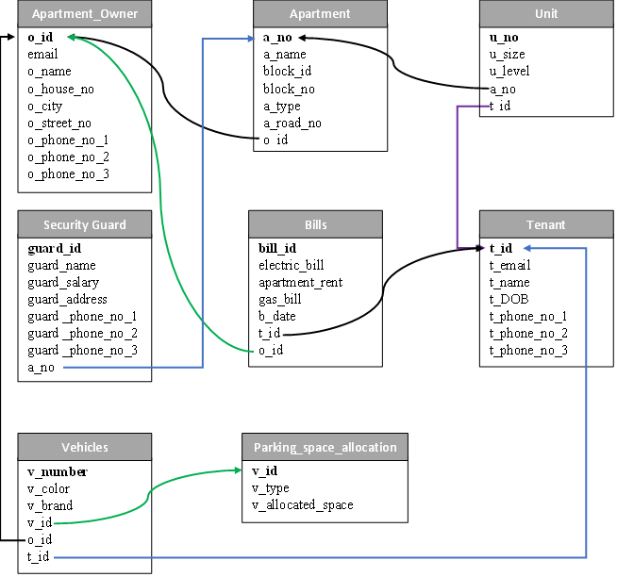**Schema Diagram:**

**Table Creation:**

**1. Apartment_owner table:**

1. create table apartment_owner (o_id number(10)primary key, o_name varchar2(15), email varchar2(40), o_city varchar2(15), o_house_no number(5), o_street_no number(5), owner_phone_no_1 varchar2(11), owner_phone_no_2 varchar2(11), owner_phone_no_3 varchar2(11));
2. ALTER TABLE apartment MODIFY a_name NOT NULL;
3. ALTER TABLE apartment MODIFY block_id NOT NULL;
4. ALTER TABLE apartment MODIFY block_no NOT NULL;
5. ALTER TABLE apartment MODIFY a_road_no NOT NULL;
6. 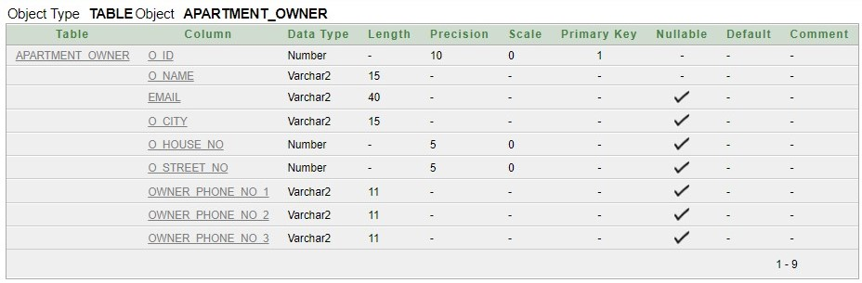ALTER TABLE apartment_owner ADD CONSTRAINT ou UNIQUE (owner_phone_no_1);

**2. Apartment table:**

1. create table apartment(a_no number(10)primary key, a_name varchar2(15), block_id varchar2(5), block_no varchar2(5), a_type varchar2(15), a_road_no number(3), o_id number(10), FOREIGN KEY(o_id) REFERENCES apartment_owner(o_id));
2. ALTER TABLE apartment_owner MODIFY o_name NOT NULL;

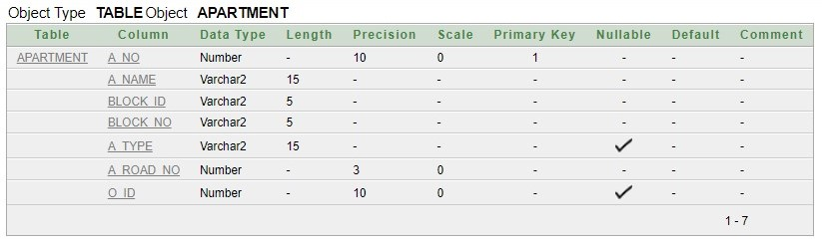

**3. Tenant table:**

1. create table tenant(t_id number(10)primary key, t_name varchar2(15), t_email varchar2(40), t_DOB date, t_phone_no_1 varchar2(11), t_phone_no_2 varchar2(11), t_phone_no_3 varchar2(11));
2. ALTER TABLE tenant MODIFY t_name NOT NULL;
3. 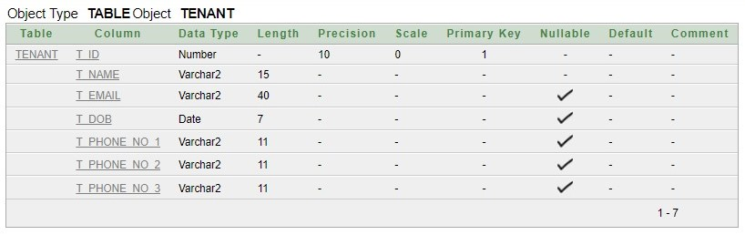ALTER TABLE tenant ADD CONSTRAINT tu UNIQUE (t_phone_no_1);

**4. Unit Table:**

1. Table

   Description automatically generatedcreate table unit(u_no varchar2(10)primary key, u_size number(5), u_level number(2), a_no number(10), t_id number(10), FOREIGN KEY(a_no) REFERENCES apartment(a_no), FOREIGN KEY(t_id) REFERENCES tenant(t_id));

**5. Security_guard table:**

1. create table security_guard(guard_id number(10)primary key, guard_name varchar2(15), guard_salary number(6), guard_address varchar2(35), guard_phone_no_1 varchar2(11), guard_phone_no_2 varchar2(11), guard_phone_no_3 varchar2(11), a_no number(10), FOREIGN KEY(a_no) REFERENCES apartment(a_no));
2. ALTER TABLE security_guard MODIFY guard_name NOT NULL;
3. 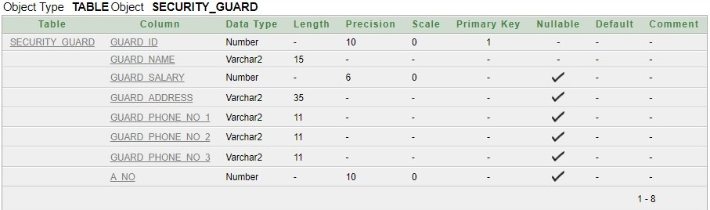ALTER TABLE security_guard ADD CONSTRAINT su UNIQUE (guard_phone_no_1);

**6. Bills table:**

1. create table bills(bill_id varchar2(10)primary key, electric_bill number(5),apartment_rent number(6), gas_bill number(5), b_date date, o_id number(10), t_id number(10), FOREIGN KEY(o_id) REFERENCES apartment_owner(o_id), FOREIGN KEY(t_id) REFERENCES tenant(t_id));
2. ALTER TABLE bills MODIFY electric_bill NOT NULL;
3. ALTER TABLE bills MODIFY apartment_rent NOT NULL;
4. ALTER TABLE bills MODIFY gas_bill NOT NULL;
5. ALTER TABLE bills MODIFY b_date NOT NULL;
6. ALTER TABLE bills MODIFY t_id NOT NULL;
7. 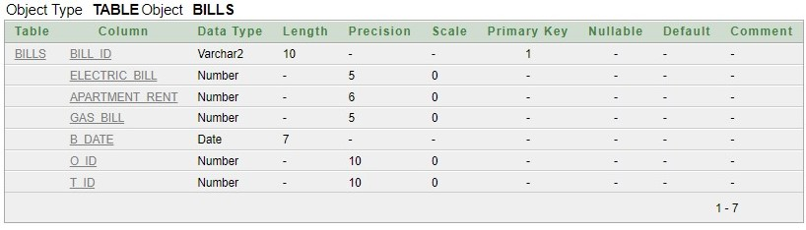ALTER TABLE bills MODIFY o_id NOT NULL;

**7. Parking_Space_Allocation table:**

1. create table parking_space_allocation (v_id varchar2(10) primary key, v_tpe varchar2(10), v_allocated_space number(3));
2. ALTER TABLE parking_space_allocation MODIFY v_tpe NOT NULL;
3. ALTER TABLE parking_space_allocation MODIFY v_allocated_space NOT NULL;

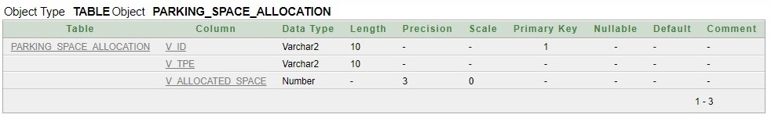**8. Vehicles table:**

1. create table vehicles(v_number number(10)primary key, v_color varchar2(10), v_brand varchar2(15), v_id varchar2(10), o_id number(10), t_id number(10), FOREIGN KEY(v_id) REFERENCES parking_space_allocation(v_id), FOREIGN KEY(o_id) REFERENCES apartment_owner(o_id), FOREIGN KEY(t_id) REFERENCES tenant(t_id));
2. 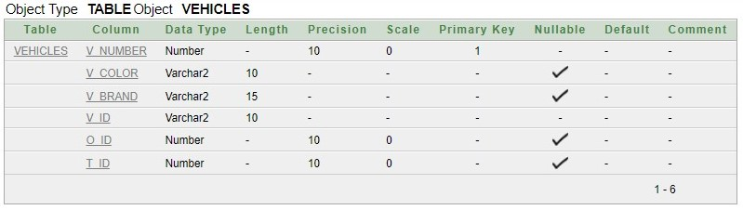ALTER TABLE vehicles MODIFY v_id NOT NULL;

**Sequences:**

1. CREATE SEQUENCE apartment_owner_id INCREMENT BY 10 START WITH 10;
2. CREATE SEQUENCE apartment_no INCREMENT BY 1 START WITH 101;
3. CREATE SEQUENCE guard_id INCREMENT BY 1 START WITH 2001;
4. CREATE SEQUENCE t_id INCREMENT BY 1 START WITH 1001;

**User Creation:**

1. create user owners identified by apartment;
2. grant connect, resource, unlimited tablespace to owners;
3. Grant create view to owners;
4. ALTER USER owners DEFAULT TABLESPACE USERS;
5. ALTER USER owners TEMPORARY TABLESPACE TEMP;

**Data Insert:**

**1. Appartment_Owner table:**

1. insert into apartment_owner values (APARTMENT_OWNER_ID.nextval, 'Faysal', 'faysal@gmail.com', 'Rajshahi', 02, 03,'01737498963', '01774595705', '01718822355');
2. insert into apartment_owner values (APARTMENT_OWNER_ID.nextval, 'Lamyea', 'lamyea@gmail.com', 'Barisal', 08, 07,'01319595261', null, null);
3. insert into apartment_owner values (APARTMENT_OWNER_ID.nextval, 'Safkat', 'safkat@gmail.com', 'Chattogram', 04, 09,'0189278712', '01819940392', null);
4. insert into apartment_owner values (APARTMENT_OWNER_ID.nextval, 'Ajmi', 'ajmi@gmail.com', 'Faridpur', 16, 1,'01312654585', null, null);
5. insert into apartment_owner values (APARTMENT_OWNER_ID.nextval, 'Sayem', 'Sayem@gmail.com', 'Dhaka', 17, 7,'01942518639', null, null);
6. insert into apartment_owner values (APARTMENT_OWNER_ID.nextval, 'Shairy', 'shairy@gmail.com', 'Rajshahi', 3, 8,'01795260274', null, null);
7. insert into apartment_owner values (APARTMENT_OWNER_ID.nextval, 'Shifa', 'Shifa@gmail.com', 'Dhaka', 15, 9,'01745356598', 'null', 'null');

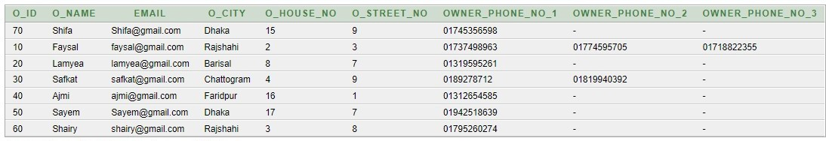

**2. Apartment Table:**

1. insert into apartment values (APARTMENT_NO.nextval, 'Padma', 'A', 'A1', 'Residential', 1, 10);
2. insert into apartment values (APARTMENT_NO.nextval, 'Meghna', 'B', 'B4', 'Comercial', 7, 10);
3. insert into apartment values (APARTMENT_NO.nextval, 'Jamuna', 'C', 'C1', 'Residential', 9, 20);
4. insert into apartment values (APARTMENT_NO.nextval, 'Karnaphuli', 'D', 'D5', 'Residential', 2, 30);
5. insert into apartment values (APARTMENT_NO.nextval, 'Shitalokkha', 'E', 'E7', 'Residential', 11, 40);
6. insert into apartment values (APARTMENT_NO.nextval, 'Buriganges', 'F', 'F9', 'Residential', 5, 50);
7. 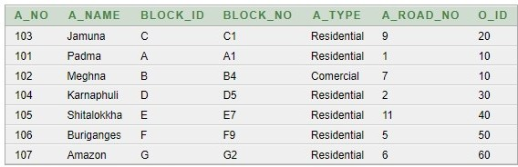insert into apartment values (APARTMENT_NO.nextval, 'Amazon', 'G', 'G2', 'Residential', 6, 60);

**3. Tenant Table:**

1. insert into tenant values (t_id.nextval, 'Monalisha', 'monalisha@yahoo.com', to_date('21-04-1997','dd-mm-yyyy'), '01732100203', null, null);
2. insert into tenant values (t_id.nextval, 'Ayesha', 'ayesha@yahoo.com', to_date('01-01-1988','dd-mm-yyyy'), '01766692501', '01819734712', null);
3. insert into tenant values (t_id.nextval, 'Upanta', 'upanta@yahoo.com', to_date('09-11-1973','dd-mm-yyyy'), '01812383971', null, null);
4. insert into tenant values (t_id.nextval, 'Samiya', 'samiya@yahoo.com', to_date('05-07-2001','dd-mm-yyyy'), '01612572333', null, null);
5. insert into tenant values (t_id.nextval, 'Sadia', 'sadia@yahoo.com', to_date('20-09-1966','dd-mm-yyyy'), '01317571923', null, null);
6. 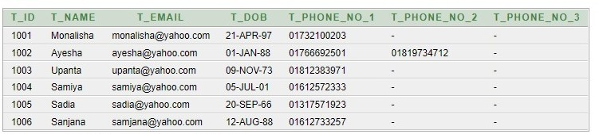insert into tenant values (t_id.nextval, 'Sanjana', 'samjana@yahoo.com', to_date('12-08-1988','dd-mm-yyyy'), '01612733257', null, null);

**4. Unit Table:**

1. insert into unit values ('A', 5000, 2, 101, 1001);
2. insert into unit values ('B', 3400, 5, 101, 1002);
3. insert into unit values ('C', 4100, 7, 103, 1003);
4. insert into unit values ('D', 2100, 13, 104, 1004);
5. insert into unit values ('E', 2700, 12, 106, 1005);
6. insert into unit values ('F', 2400, 4, 103, 1006);

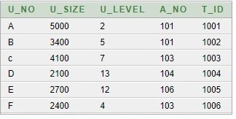**5. Security_Guard table:**

1. insert into security_guard values (GUARD_ID.nextval, 'Sayem', 10000, 'Kanchan, Dhaka', '01828968554', null, null, 101);
2. insert into security_guard values (GUARD_ID.nextval, 'Ashik', 13000, 'Veramara, Kustia', '01876207688', null, null, 101);
3. insert into security_guard values (GUARD_ID.nextval, 'Sadik', 10000, 'Fatikchari, Chottogram', '01850901798', null, null, 102);
4. insert into security_guard values (GUARD_ID.nextval, 'Salam', 12000, 'Halishahan, Manikgonj', '01910857903', '01745256589', null, 103);
5. insert into security_guard values (GUARD_ID.nextval, 'Abdul', 15000, 'Kaola, Rajshahi', '01916803884', null, null, 104);
6. insert into security_guard values (GUARD_ID.nextval, 'Roni', 17000, 'Laxmipur, Rajshahi', '01731451540', null, null, 105);

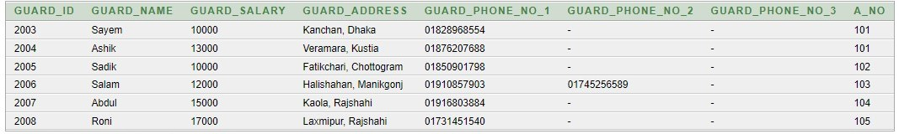

**6. Bills Table**:

1. insert into bills values('Jan2207', 2000, 27000, 1500, to_date('07-02-2022','dd-mm-yyyy'), 10, 1001);
2. insert into bills values('Mar2203', 2500, 32000, 1000, to_date('09-04-2022','dd-mm-yyyy'), 10, 1002);
3. insert into bills values('Sept2107', 2800, 42000, 2000, to_date('01-10-2021','dd-mm-yyyy'), 20, 1003);
4. insert into bills values('Dec2113', 1800, 3700, 1500, to_date('13-01-2022','dd-mm-yyyy'), 30, 1004);
5. insert into bills values('Oct2207', 2000, 40000, 1000, to_date('10-11-2022','dd-mm-yyyy'), 50, 1005);
6. 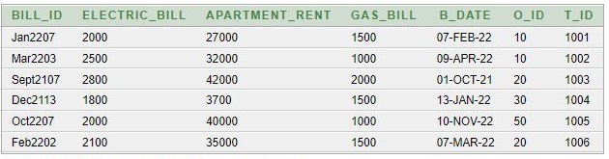insert into bills values('Feb2202', 2100, 35000, 1500, to_date('07-03-2022','dd-mm-yyyy'), 20, 1006);

**7. Parking_Space_Allocation Table:**

1. insert into parking_space_allocation values ('C1211', 'Car', 40);
2. insert into parking_space_allocation values ('C2122', 'Car', 40);
3. insert into parking_space_allocation values ('C3132', 'Car', 40);
4. insert into parking_space_allocation values ('B1621', 'Bike', 10);
5. insert into parking_space_allocation values ('C1622', 'Car', 40);
6. 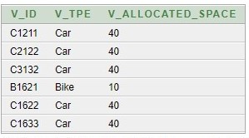insert into parking_space_allocation values ('C1633', 'Car', 40);

**8. Vehicles Table:**

1. insert into vehicles values (256012, 'black', 'Lancer', 'C1211', null, 1001);
2. insert into vehicles values (256013, 'grey', 'Lamborghini', 'C2122', null, 1001);
3. insert into vehicles values (256014, 'red', 'Buggati', 'C3132', 10, null);
4. insert into vehicles values (256015, 'blue', 'Kawashaki', 'B1621', 20, null);
5. insert into vehicles values (256016, 'yellow', 'Honda', 'C1622', 40, null);
6. 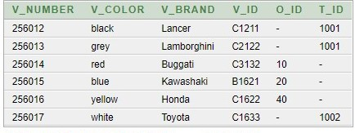insert into vehicles values (256017, 'white', 'Toyota', 'C1633', null, 1002);

**Queries Questions and Answers:**

**Single row function:**

1. Display those apartment owner names whose name consists of more than 4 letters.

Ans: **select o_name from apartment_owner where length(o_name)>4;**

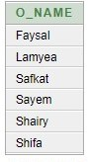

2. Display those tenants name and age who are more than 25 years old.

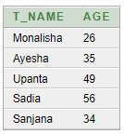Ans**: select t_name, round((sysdate-t_dob)/365) age from tenant where (sysdate-t_dob)/365>25;**

**Group function:**

1. What is the maximum apartment rent?

Ans. **select max(apartment_rent) as Maximum_Apartment_Rent from bills;**



2. Who is the oldest tenant?

****Ans: **select t_name from tenant where (sysdate-t_dob)>= (select max(sysdate-t_dob) from tenant);**

**Subquery:**

1. Which security guard has more salary than Sayem?

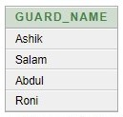Ans: **select guard_name from security_guard where guard_salary> (select guard_salary from security_guard where guard_name='Sayem');**

2. Which security guard/guards take minimum salary?

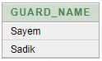Ans: **select guard_name from security_guard where guard_salary<= (select min(guard_salary) from security_guard);**

**Joining:**

1. Display guard name and the apartment name where they works.

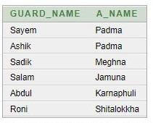Ans: **select g.guard_name, a.a_name from security_guard g, apartment a where g.a_no=(a.a_no);**

2. Display which owner have which apartment with apartment types also show them who currently doesn’t hold any apartment ownership.

Ans: **select o.o_name, a.a_name, a.a_type from apartment_owner o, apartment a where o.o_id=a.o_id(+);**

**View:**

1. Create a view which contains the apartment details of Faysal’s apartment.

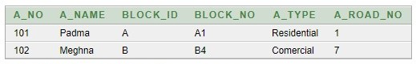Ans: **create view Faysals_Apartment as select a_no, a_name, block_id, block_no, a_type, a_road_no from apartment where o_id=(select o_id from apartment_owner where lower(o_name)='faysal');**

2. Create a view to show total bills that tenants have to paid.

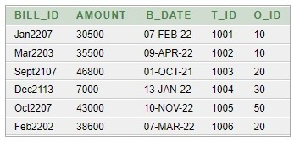Ans: **create view Total_Bills as select bill_id, electric_bill+apartment_rent+gas_bill as amount, b_date, t_id, o_id from bills;**

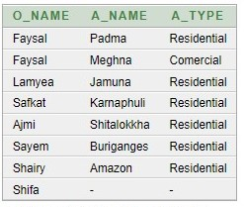

**Relational Algebra:**

1.Display only those rows of data from apartment where owner id is 10.

Ans: σo_id= 10 (*Apartment_Owner*)

2. Project guard name and salary from security guard table.

Ans: ∏guard_name, guard_salary  (Security_Guard)

3. Find the tenant whose id is 1004.

Ans: ∏t_name(σt_id= 1004 (Tenant)

4. Find the apartment owner name whose city is Rajshahi.

Ans: ∏o_name(σo_city= “Rajshahi” (Apartment_owner))

5. Find the guard id whose salary is higher than 15000.

Ans: ∏guard_id(σguard_salary> 15000 (Security_guard))

**Conclusion:**

We have successfully created a database management system for apartments. Our apartment management system is like a joint apartment management system where a group of owners can control their apartments and store all the valuable information about tenants, parking, guards, vehicles, and so on. From our database management system, owners can easily find a tenant’s information. They can also check the bills for their apartments. In the future, we can improve our database by updating our parking system. We can add some other details, such as when a car enters or leaves parking or for how much time a vehicle is parked. Also, in the future, we can separate owners and make a database for each owner to control their apartments even more efficiently.